Module 1– Overview of IT Industry

World Wide Web & How Internet Works
Que: : Research and create a diagram of how data is transmitted from a client to a server over the internet.

Network Layers on Client and Server

Types of Internet Connections
Que: Research different types of internet connections (e.g., broadband, fiber, satellite) and list their pros and cons.
Ans:
1.DSL:
Pros-Widely available in urban and suburban areas.
This is affordable.
Cons-speed depends on distance
Slower than cable and fiber .
2.cable internet:
Pros-high speed
Widely available in cities and town.
More stable than DSL
Cons-slightly more expansive than dsl
3.fiber-optic internet
Pros-extremely fast
Symmetrical download and upload speed.
Very low latency and high reliability.
Cons-limited available
Higher cost compared to DSL/cable
4.satellite internet:
Pros-available almost everywhere.
No need for cabels or phone lines

Cons-high latency
Weather can affect signal
Higher cost for lower speeds
5.wireless:
Pros-good for rural areas without wired infrastructure
No cables required.
Cons- Requires line of sight to tower.`
Speeds and stability depend on weather and obstructions.
6.BPL(broadband over power lines):
Pros- No extra wiring needed.
Can reach some areas not served by other methods.
Cons- Limited availability.
Can suffer from interference and slower speeds.
Protocols
Que: Simulate HTTP and FTP requests using command line tools (e.g., curl).

Application Security
Que: Identify and explain three common application security vulnerabilities. Suggest possible solutions.

Software Applications and Its Types

Que: Identify and classify 5 applications you use daily as either system software or application software.
Ans: firstly I use windows .
I use codeblock for programming .
I use google for browsing the internet
I use Microsoft word ,it helps to creating and edit documents
I also use whatsapp it let me send messages,calls etc.

Software Architecture
Que: Design a basic three-tier software architecture diagram for a web application.
Ans:
1.presentation tier(client/user interface):
Web browser or interface
Displays UI,sends user requests to the server
Ex. Html ,css, javascript,etc
2.application tier(business logic layer):
Web server and backend application.
Processes requests, applies business logic.
Examples: Node.js, Java Spring Boot, Python etc.
3.data tier:
Database server where data is stored/retrieved.
Examples: MySQL, PostgreSQL, MongoDB.

Layers in Software Architecture
Que: Create a case study on the functionality of the presentation, business logic, and data access layers of a given software system.

Software Environments
Que:

Types of Softwar
Que: Create a list of software you use regularly and classify them into the following categories: system, application, and utility software.
Ans:
1.system software-windows 11, android, macos
2.application software-google,whatsapp,spotify,MS word
3.utility software-antivirus,backup tools

Application software
Que: Write a report on the various types of application software and how they improve productivity.
Ans:
Word processor- make creating/editing documents
Spreadsheet- automate calculations and organize data.
Graphic tools- help design and edit media quickly
communication apps– enable quick teamwork and sharing.

Software Development Process
Que: Create a flowchart representing the Software Development Life Cycle (SDLC).
Ans:
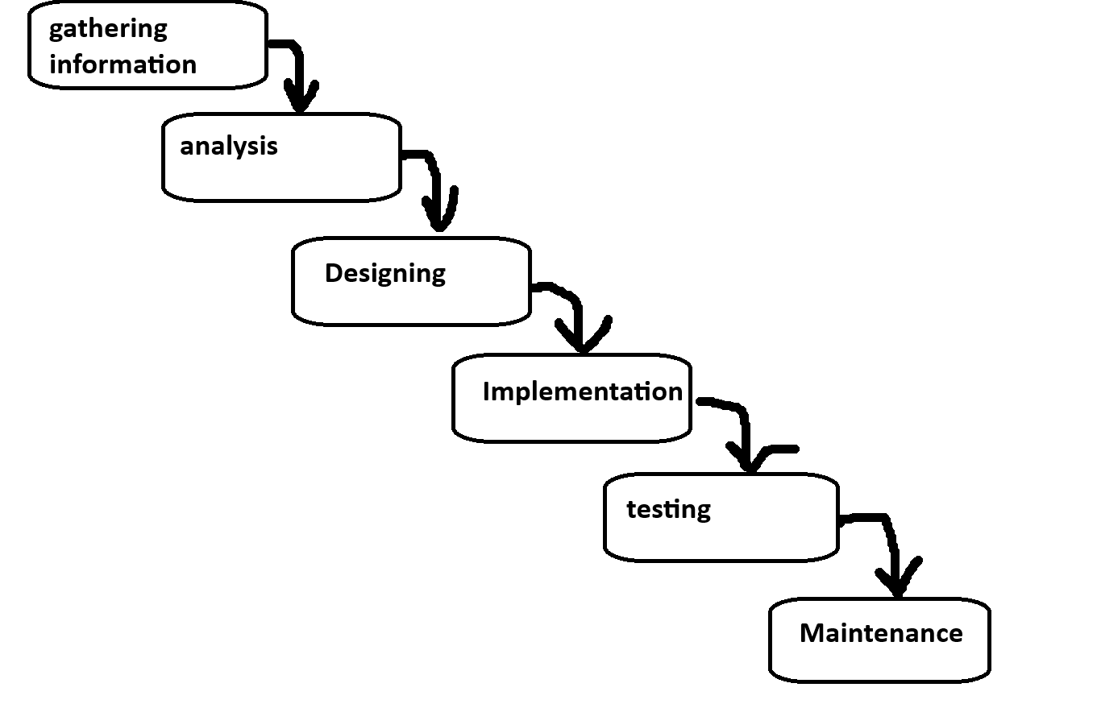

Software Analysis
Que: Perform a functional analysis for an online shopping system.
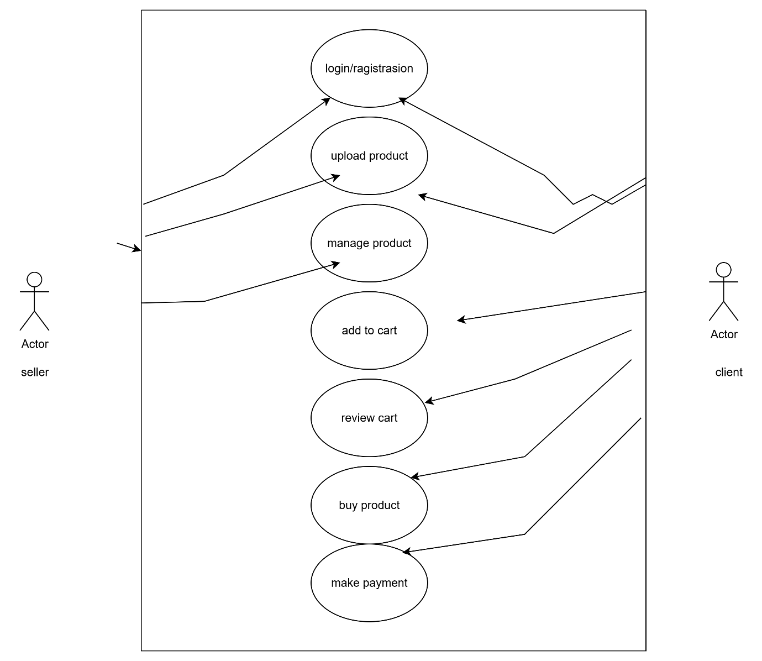

System Design
Que: Design a basic system architecture for a food delivery app.
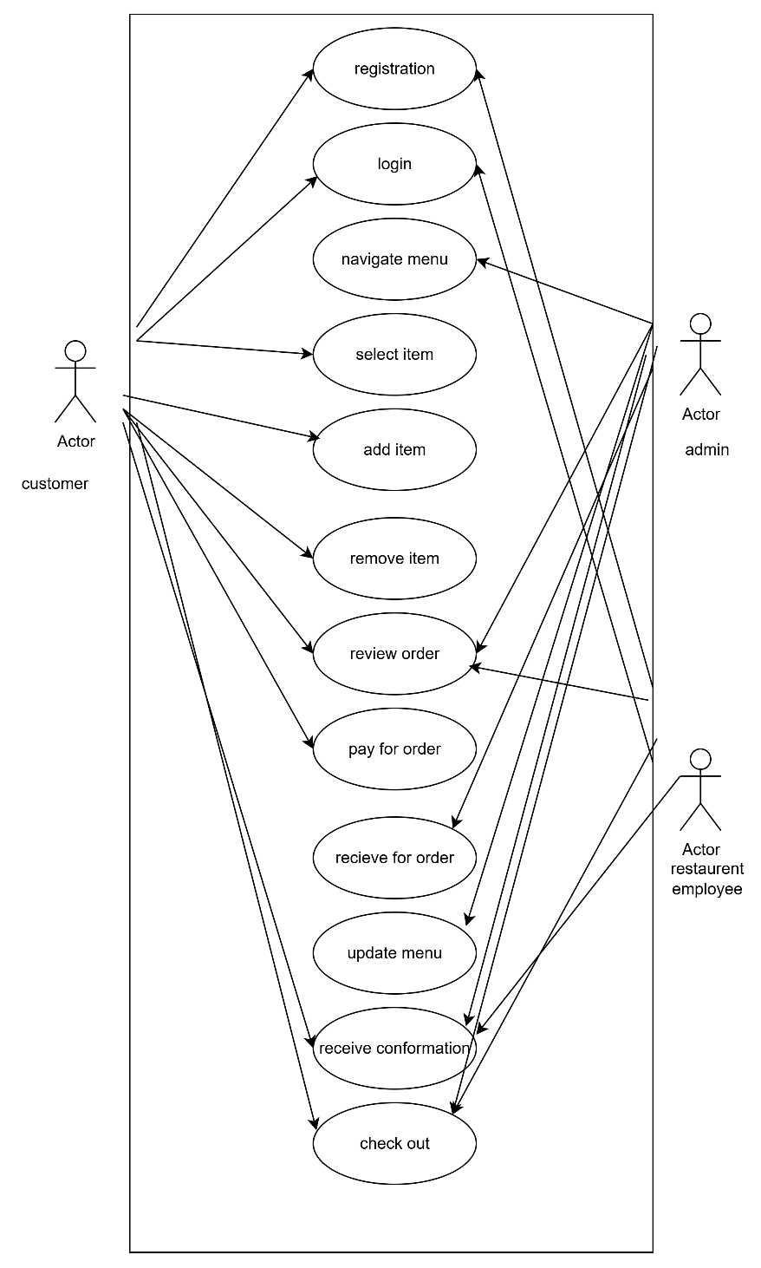

DFD(Data Flow Diagram)
Que: Create a DFD for a hospital management system.
Ans:
